Lightweight Directory Access Protocol (LDAP)

Complete by: Nikita Prohcarau

Git: https://github.com/Nikita-Prohorov/observability_module

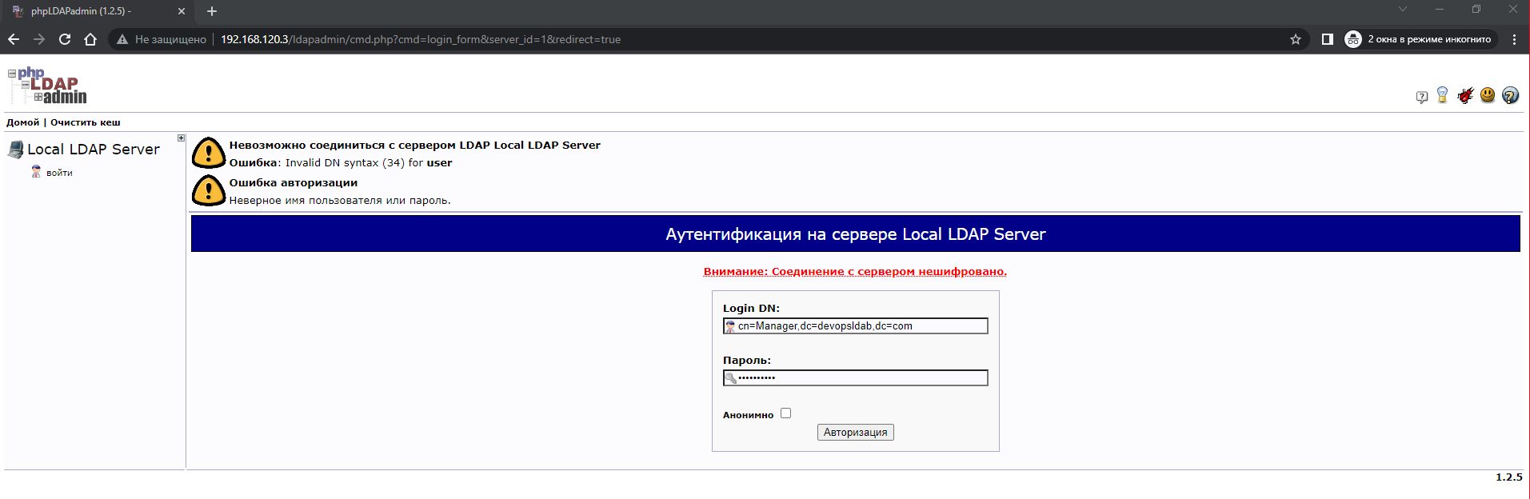

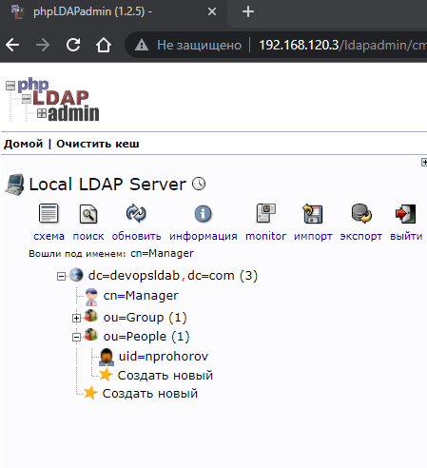

Connect and login to PHPAdmin GUI after configure LDAP Server

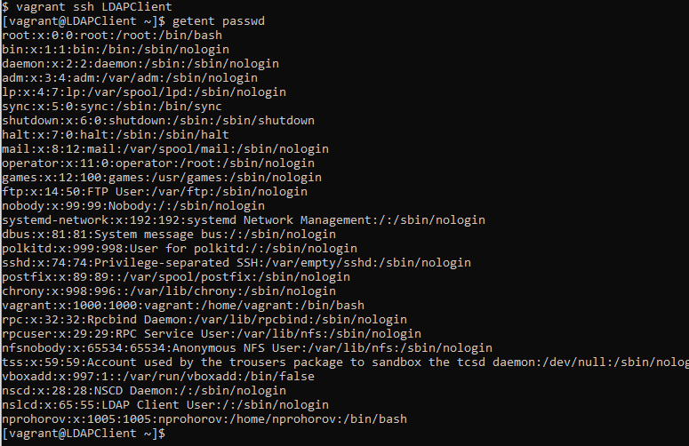

User in list after configure Client

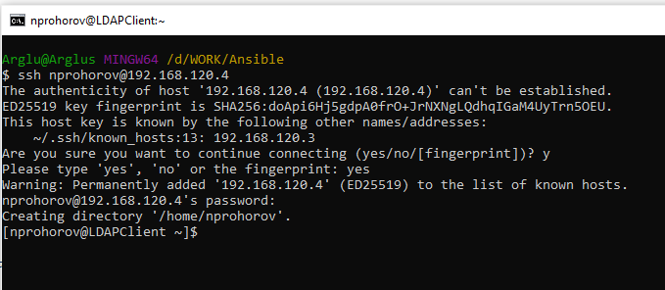

Connect SSH